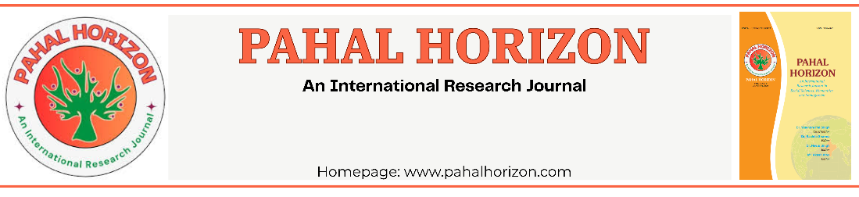
Title Of The Paper [in 14 font size]
Author¹, Author²
^{1, 2} Designation and Affiliation [in 11 & 10 Font Size respectively]
ABSTRACT
Provide a concise summary of the manuscript including the research objective, methodology, major findings, and conclusion. The abstract should clearly highlight the significance and contribution of the work. Avoid references, citations, and undefined abbreviations. Recommended length: 150–250 words. Font size: 9 pt.

Keyword: write related keywords in 9 font size.
1. INTRODUCTION
The introduction section should provide background information about the selected research topic and explain the importance of the study. Authors should clearly define the research problem, objectives, motivation, and scope of the work. This section should help readers understand the context of the research and the need for the proposed study or solution.
2. LITERATURE REVIEW
The literature review section should summarize previously published research works related to the topic. Authors should discuss existing methods, technologies, models, or approaches used by other researchers and identify research gaps or limitations in earlier studies. This section should demonstrate the understanding of current developments in the field.

3. METHODOLOGY / PROPOSED WORK
The methodology section should explain the procedures, techniques, tools, algorithms, materials, or experimental setup used to carry out the research work. Authors should describe the proposed approach in a clear and systematic manner so that the work can be understood and reproduced easily. Diagrams, flowcharts, and mathematical models may also be included where necessary.

4. RESULTS AND DISCUSSION

The results and discussion section should present the outcomes of the research work using tables, graphs, figures, or analytical observations. Authors should explain the significance of the obtained results and compare them with existing methods or expected outcomes wherever applicable. Proper interpretation and analysis of the results should be included in this section.

5. CONCLUSION

The conclusion section should summarize the overall research work and highlight the major findings and contributions of the study. Authors should briefly discuss whether the objectives of the work were successfully achieved and explain the practical significance of the results obtained through the research.

6. FUTURE SCOPE

The future scope section may include possible improvements, extensions, or additional research opportunities related to the proposed work. Authors may discuss advanced techniques, further optimizations, or new application areas that can be explored in future studies.

7. REFERENCES

The references section should contain all the sources, research papers, books, journals, websites, and articles cited in the manuscript. Authors should ensure that references are properly formatted and consistently written according to the prescribed citation style throughout the paper in 8 pt.

Guidelines :

- Use Times New Roman font throughout the manuscript.
- Use 10 pt font size for the complete manuscript content.
- Maintain 1.0 line spacing throughout the document.
- Do not use bold, italics, or underline unnecessarily in the manuscript.
- The paper title should be center aligned and written clearly at the top of the first page.
- Author names, affiliations, and email addresses should be center aligned below the title.
- The abstract should briefly describe the objective, methodology, results, and conclusion of the research work in 150–250 words.
- Provide 4–6 relevant keywords below the abstract section.
- The Introduction section should explain the background, objectives, problem statement, and significance of the study.
- The Literature Review section should summarize previous research works and identify research gaps.
- The Methodology / Proposed Work section should clearly explain the methods, algorithms, tools, materials, or procedures used in the research.
- The Results and Discussion section should present observations, analysis, comparisons, tables, graphs, and interpretation of obtained results.
- The Conclusion section should summarize the major findings and overall outcome of the research work.
- The Future Scope section may include possible improvements, extensions, or further research opportunities related to the work.
- The References section should include all cited journals, books, articles, conference papers, and websites in proper citation format in 8pt.
- All figures and tables should be properly numbered sequentially.
- Figure titles and table titles should be center aligned and written in 8 pt font size.
- Sources below figures and tables, if included, should also be center aligned and written in 8 pt font size.
- Ensure that all images, tables, and graphs are clear, readable, and properly placed within the manuscript.
- Maintain proper margins, alignment, and formatting consistency throughout the paper.

